CompTia A+
A+ - Understanding and maintenance of Networks

Assignment-3
Day 2: Routers and SwitchesTheory (30 min):Basic functions and differences between routers and switches.Practical (30 min):Identify ports and LEDs on a router and switch.
QUE-01 Draw a labelled diagram of a typical home WiFi router and a network switch, clearly marking at least 3 different ports (such as WAN, LAN, Console) and the location of status LEDs.
ANS
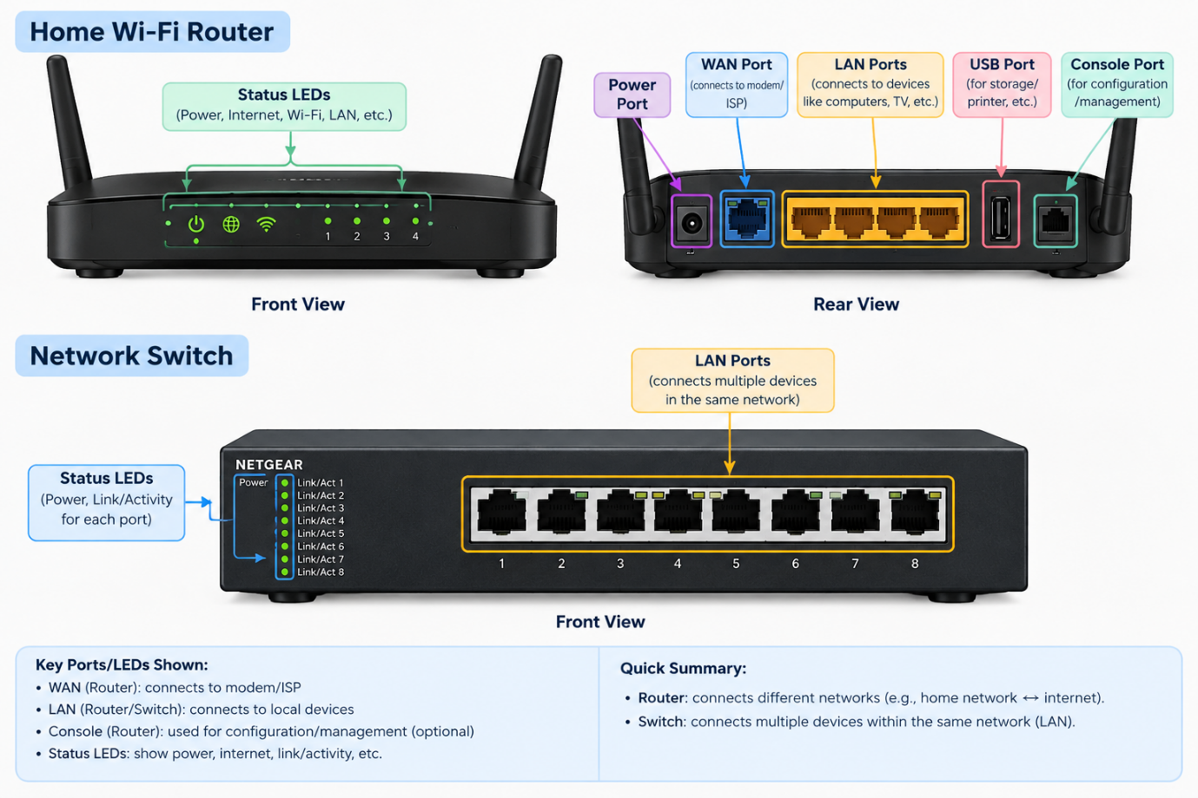

QUE-02 List 3 key differences between routers and switches in terms of their main functions and how they handle network traffic.<br><br><em><strong>Hint:</strong> Think about how each device deals with IP addresses, MAC addresses, and the types of networks they connect.</em>
ANS
Basis | Router | Switch
1. Main Function | Connects different networks, such as a home network and the internet. | Connects multiple devices within the same local area network (LAN).
2. Address Used | Uses IP addresses to route data packets between networks. | Uses MAC addresses to forward data frames to the correct device.
3. Network Traffic | Directs traffic between different networks and selects an appropriate route for packets. | Forwards traffic within a LAN, typically sending frames only to the relevant port based on its MAC address table.

QUE-03 Take a real or virtual image of a router and a switch (from your home, lab, or Google Images), and identify the following on each: Power port, at least 2 Ethernet ports, and any LED indicators. Annotate the image or describe their position and purpose.
ANS
1. Wi-Fi Router
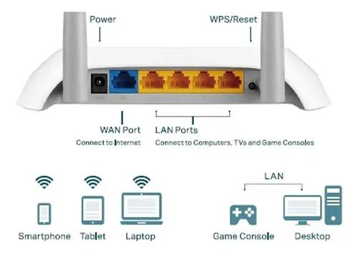
Component | Position | Purpose
Power Port | Usually at the back | Connects the power adapter to turn on the router.
Ethernet LAN Ports (1 and 2) | Usually at the back | Connect computers or other wired devices to the network.
WAN/Internet Port | Usually at the back, separate from LAN ports | Connects the router to the modem or internet connection.
LED Indicators | Usually on the front or near the ports | Show power, internet connection, Wi-Fi status, and network activity.
Source: Open University – Router Ports.
2. Network Switch
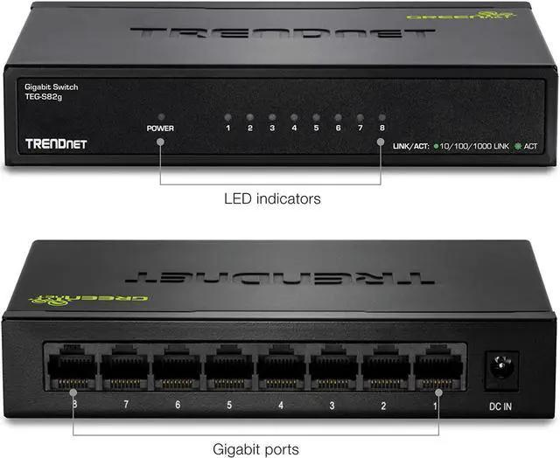

Component | Position | Purpose
Power Port | Usually at the back or side | Connects the power supply to the switch.
Ethernet Port 1 | On the front panel of most switches | Connects a computer or another network device.
Ethernet Port 2 | Next to the other Ethernet ports | Connects another computer or network device.
LED Indicators | Beside or above the Ethernet ports | Show whether a port is connected and whether data is being transmitted.
Source: Cisco – Network Switch Ports and LEDs.

QUE-04 Imagine you are setting up a small gaming café network for IPL streaming and multiplayer matches. Write a short scenario explaining which device (router or switch) you would connect first to the ISP line, and how you would connect 8 gaming PCs to the network. Justify your choices.
ANS
Scenario: Setting Up a Small Gaming Café Network
I am setting up a small gaming café with 8 gaming PCs for multiplayer games and live IPL streaming.
First, I would connect the router to the ISP's internet connection through the modem or ONT. The router directs internet traffic and manages communication between the café's local network and the internet.
Next, I would connect one of the router's LAN ports to a network switch using an Ethernet cable. Then, I would connect all 8 gaming PCs to the switch using separate Ethernet cables.

Network layout:
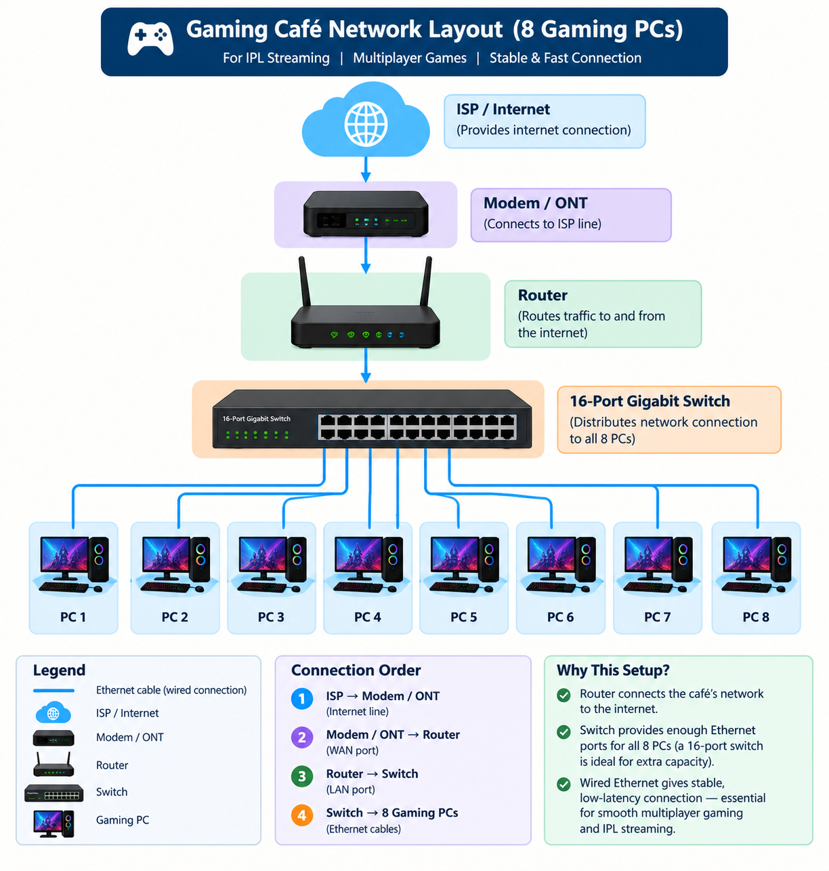Justification:
- Router: Connects the café's network to the internet and directs traffic between networks.
- Switch: Provides enough wired Ethernet ports for all 8 PCs.
- Ethernet cables: Provide stable, low-latency connections, which are important for multiplayer gaming and smooth streaming.
I would choose a gigabit switch with at least 8 usable PC ports. Since one port connects to the router, a typical 8-port switch would need to be supplemented by another port on the router; a 16-port switch is a convenient choice.

